عدد أسماء أجهزة الطبخ اسفل كل صورة

ثلاجة فرن

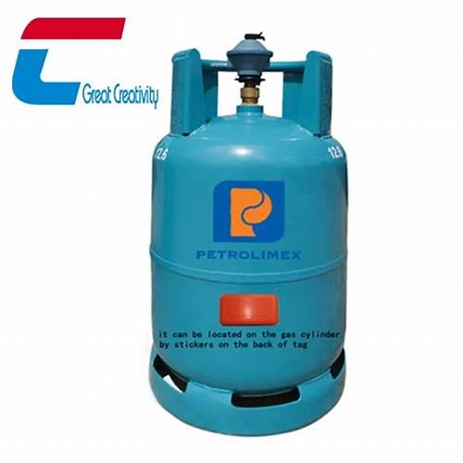

غاز غلاية كهربائية

رتب الخطوات التالية

3

2

4

1